Student Text

Mother to Son

Well, son, I'll tell you:
Life for me ain't been no crystal stair.
It's had tacks in it,
And splinters,
And boards torn up,
And places with no carpet on the floor—
Bare.
But all the time
I'se been a-climbin' on,
And reachin' landin's,
And turnin' corners,
And sometimes goin' in the dark
Where there ain't been no light.
So, boy, don't you turn back.
Don't you set down on the steps.
'Cause you finds it's kinder hard.
Don't you fall now—
For I'se still goin', honey,
I'se still climbin',
And life for me ain't been no crystal stair.
- Langston Hughes

Teacher Support
Lexile Levels and Qualitative Complexity Traits of Text

Mother to Son Lexile: 4th-5th; figurative language demands increase complexity; unusual language patterns may cause difficulties in comprehension
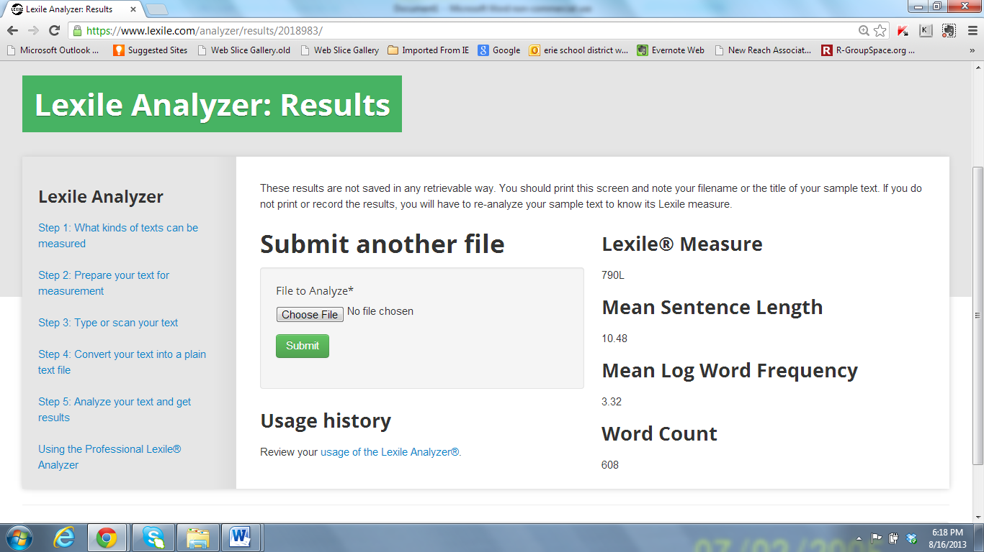

Teacher Support
Close Reading Lessons Plans
Mother to Son By Langston Hughes
Grade 5 Close Reading Lesson

Every Close Reading Lesson targets Reading Standards 1 and 10.
Standard RL.5.1 – Quote accurately from a text when explaining what the text says explicitly and when drawing inferences from the text
Standard RL.5.10 – By the end of the year, read and comprehend literature, including stories, dramas, and poetry, at the high end of the grades 4-5 text complexity band independently and proficiently.

First Reading:
Prior to the reading, teacher reminds students that there are different purposes in reading. Sometimes a text is read only one time and completely understood. Some texts, however, like this poem, deserve to be read several times to understand and appreciate the meaning.
Students read the poem independently. (Striving readers may be read the poem prior to this reading.) Students are instructed to circle any words that cause them to struggle.
Goal for this reading is for students to read the text in its entirety to gain an understanding of the overall
meaning.

Second Reading:
Teacher does a read aloud without any stops. Students are instructed to pay close attention to the words they circled in the first reading.
Goal is for students to hear the text in its entirety to gain an understanding of the overall meaning of the poem.

Third Reading (Part A on Recording Form):
Students complete the text dependent questions. This can be done individually or in partners. There should be partner discussion and then whole class discussion revolving around each question.
The goal of this reading would be deeper comprehension of what is said explicitly and what can be inferred.

Fourth Reading (Part B on Recording Form):
Students will paraphrase each stanza. The goal of this reading is to synthesize the poet’s words.

Written Response (Part C on Recording Form) :
Standard RL.5.4 – Determine the meaning of words and phrases as they are used in a text, including figurative language such as metaphors and similes
Standard RL.5.2 – Determine a theme of a story, drama, or poem from details in the text, including how characters in a story or drama respond to challenges or how the speaker in a poem reflects upon a topic; summarize the text
Standard W.5.9 – Draw evidence from literary or informational texts to support analysis, reflection and research

Student Support
Close Reading Recording Form

Name _____________________________________________________

Day 1 - Part A: Return to the poem to answer each of the following questions.
- (1) Who is speaking? Who is the narrator speaking to? How do you know?

- (1) What is meant by ‘no crystal stair’?

- (1) Has the narrator had an easy life? What evidence from this stanza supports your answer?

- (1) The first stanza ends with the word ‘bare’. Besides the stairs being bare, what else does the narrator mean is bare?

- (2) When life is challenging, does the narrator give up? How do you know? What words tell you that answer?

Student Support
Close Reading Recording Form
- (2) What is the symbolism in the phrase ‘turnin’ corners’?

- (2) The narrator speaks of dark times. Is she speaking of only the light in the stairway or something more? If something, what is she referring to?

- (3) What advice is the narrator offering? What words in this stanza of the poem provide you the answer?

- (3) What does the narrator intend to do? How do you know?

- (3) What is the significance of the metaphor ‘… life for me ain’t been no crystal stair’?

Name _____________________________________________________
Student Support
Close Reading Recording Form
Day 2 - Part B: Paraphrase each stanza into your own words.
Stanza 1
_________________________________________________________________________________________________________________________________________________________________________________________________________________________________

Stanza 2
_________________________________________________________________________________________________________________________________________________________________________________________________________________________________

Stanza 3
_________________________________________________________________________________________________________________________________________________________________________________________________________________________________

Name _____________________________________________________
Student Support
Close Reading Recording Form

What is the theme of the poem Mother to Son? After reading Mother to Son and an informational text on figurative language, write an essay for our class literary magazine in which you discuss how Langston Hughes’ use of figurative language contributes to an understanding of the theme of this poem. Give several example/s from the poem to support your discussion.

Transition to Writing - Part C: This poet uses figurative language to create visual images which help the reader understand the theme of the poem. Prior to the Socratic Seminar, make notes about the mother’s reaction to the hardships she has endured and the message she is offering her son. Cite specific evidence from the text to support your response. Remember, you will be responding to the teaching task above in the next few days.
_________________________________________________________________________________________________________________________________________________________________________________________________________________________________________________________________________________________________________________________________________________________________________________________________________________________________________________________________________________________________________________________________________________________________________________________________________________________________________________________________________________________________________________________

